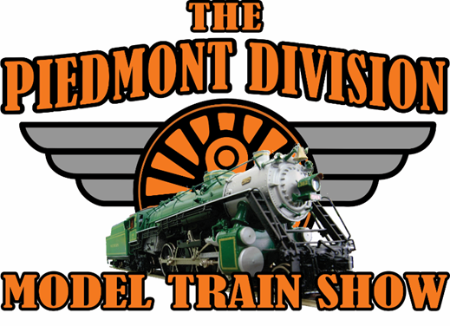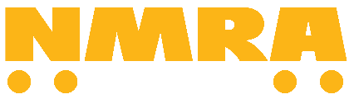

Clarence Brown Center, 5450 Highway 20, Cartersville, GA 30121

March 13th and 14th, 2027
Sponsored by the Piedmont Division, NMRA
https://thepiedmontdivisionmodeltrainshow.com

Remit to: Jim Travis
Email showmanager@themodeltrainshow.com

EXHIBIT / Layout SPACE ORDER FORM & RESERVATION REQUEST

OFFICE USE ONLY

Honorarium sent date: ________________________ Check #: ______________________________

Email confirmation sent (date) : ______________________________________________________________________________

Notes: _______________________________________________________________________________

The Piedmont Division Model Train Show

Clarence Brown Conference Center, Cartersville, GA

Layout/Exhibitor Application

Contact details
Layout Name/Scale: ________________________
Contact Name / phone / e-mail

Group /Club Name (if applicable)

________________________________________

Number of entry badges for set-up Friday______
Operations/Greeters Saturday______
Operations/Greeters/Take Down Sunday________
Name and Address for Honorarium (if paid)
__________________________________________________________________________________
Previous exhibitor | Yes / No

Layout size
Preferred Dimensions (Enter preferred dimensions you would like to exhibit at the show, including operator space)

Length: ______________ Width: ______________

Alternate Dimensions (If flexible, please list the minimum/maximum dimensions of your display)
Min. Length: _______ Min. Width: _______

Max. Length: _______ Max. Width: _______

Honorarium
Does your group require an honorarium (Payment) to participate? Yes ____No____
(In past years we have given an honorarium based on show profitability and the number of layouts. This has varied from $50 to as much as $400.
Are you willing to accept our standard honorarium based on show profits? Yes___ No___
If not, what amount do you require? $_______

Description of Layout
We will use this information to decide which layouts to accept in the event of we have more layouts than we have space. You are welcome to provide a link to your website for [some] of the answers.

Theme / overview
Prototype inspiration etc. (attach track plan / schematic)

Scale / gauge

Height of track

Style of scenery
Painted table, very realistic, etc (attach pictures)

Operations
Run trains at random, follow a timetable with train orders, allow the public to use throttles, etc

Do you have a meet and greet table / demonstration of tree making / etc
No / Yes, description

Exhibitor Terms and Conditions
The term “Exhibitor” applies to clubs, dealers, organizations or individuals presenting layouts, exhibits or displays at The Piedmont Division Model Train Show.

Exhibitor agrees to keep the display operational to the public during show hours of The Piedmont Division Model Train Show (see flyer below). Violation of this rule may lead to exclusion from future shows.

Exhibitor releases The Piedmont Division Model Train Show from all claims arising from exhibitor’s show occupancy, including, but not limited to, theft, damage or loss of property, and personal injury to any exhibitor personnel. The Piedmont Division Model Train Show assumes no liability for actions of Exhibitor personnel.

Exhibitor understands The Piedmont Division Model Train Show assumes no responsibility for any Exhibitor property or for safety of any Exhibitor personnel at the show.

Exhibitor agrees to give entry badges only to personnel actively involved in set-up, operation and take-out of the layout / display. Exhibitor badges are not to be sold.

Acceptance of Terms and Conditions
I certify that I have read the terms and conditions and agree to abide by those conditions
Club Representative’s Signature Date___________________________________________

